**Analysis of Comcast Telecom Consumer Complaints**

## **Problem Statement:**

Comcast is an American global telecommunication company. The firm has been providing terrible customer service. They continue to fall short despite repeated promises to improve. Only last month (October 2016) the authority fined them a $2.3 million, after receiving over 1000 consumer complaints. The existing database will serve as a repository of public customer complaints filed against Comcast. It will help to pin down what is wrong with Comcast's customer service.

**Dataset:**

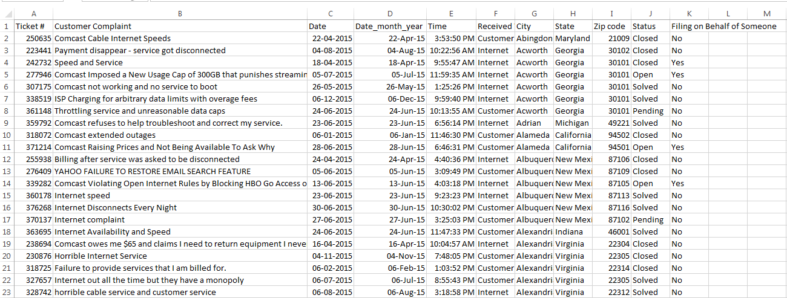

**Data Dictionary**

* Ticket #: Ticket number assigned to each complaint
* Customer Complaint: Description of complaint
* Date: Date of complaint
* Time: Time of complaint
* Received Via: Mode of communication of the complaint
* City: Customer city
* State: Customer state
* Zipcode: Customer zip
* Status: Status of complaint
* Filing on behalf of someone

**Analysis Task**

To perform these tasks, you can use any of the different Python libraries such as NumPy, SciPy, Pandas, scikit-learn, matplotlib, and BeautifulSoup.

- Import data into Python environment.  
- Provide the trend chart for the number of complaints at monthly and daily granularity levels.  
- Provide a table with the frequency of complaint types.

* Which complaint types are maximum i.e., around internet, network issues, or across any other domains.

- Create a new categorical variable with value as **Open**and **Closed**. Open & Pending is to be categorized as Open and Closed & Solved is to be categorized as Closed.  
- Provide state wise status of complaints in a stacked bar chart. Use the categorized variable from Q3. Provide insights on:

* Which state has the maximum complaints
* Which state has the highest percentage of unresolved complaints

- Provide the percentage of complaints resolved till date, which were received through the Internet and customer care calls.

The analysis results to be provided with insights wherever applicable.

# Solution:

We start by importing all libraries to perform analysis

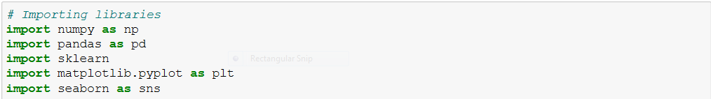

The problems are:

1. **Import data into Python environment.**



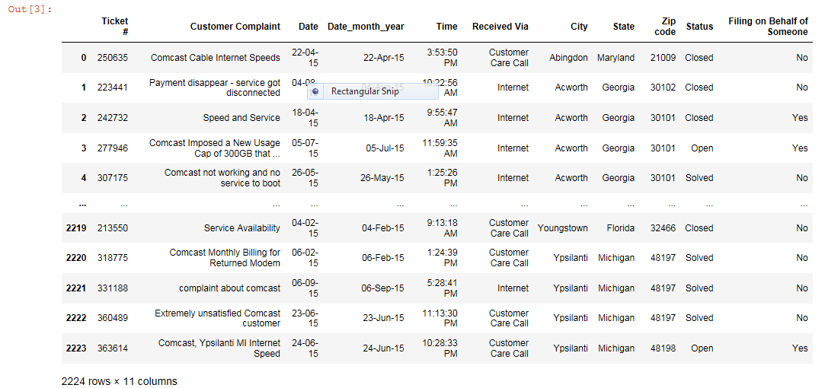

* + Now separating Date, Month & Year also creating new column separatly’
  + We drop variables like Ticket, Zipcode,Time

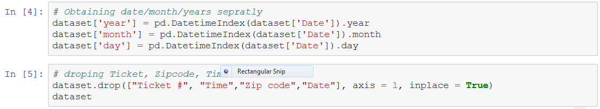

Output :-

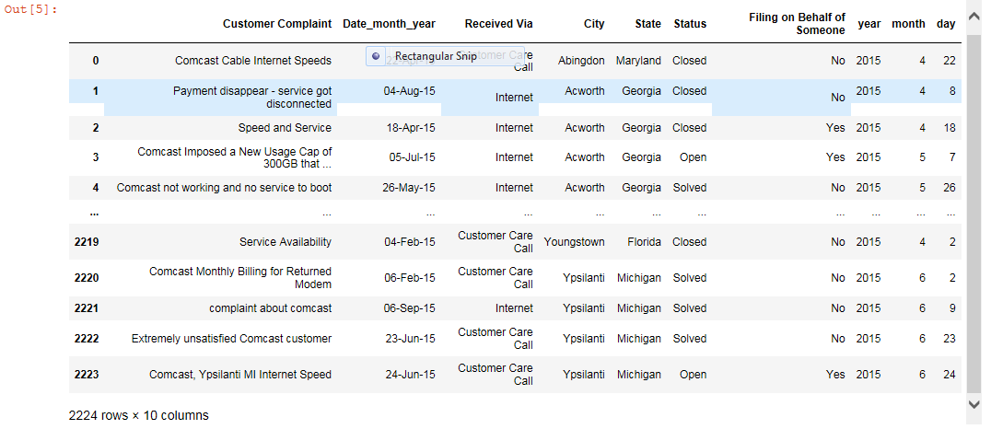

**2] Provide the trend chart for the number of complaints at monthly and daily granularity levels.**

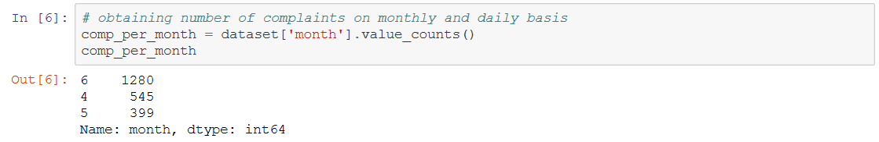

##### Output is clearly shows that June month has highest number of complaints lodge with 1280 numbers



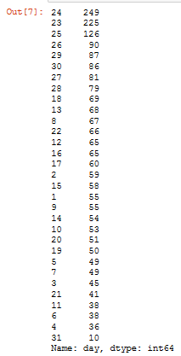

Plotting Chart for number of complaints monthly :-



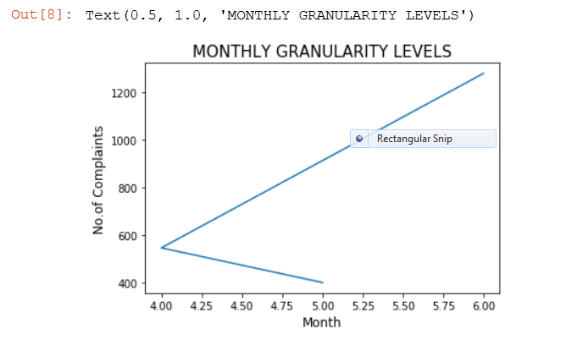

Plotting Chart for number of complaints Daily :-

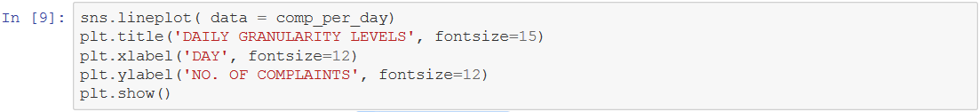

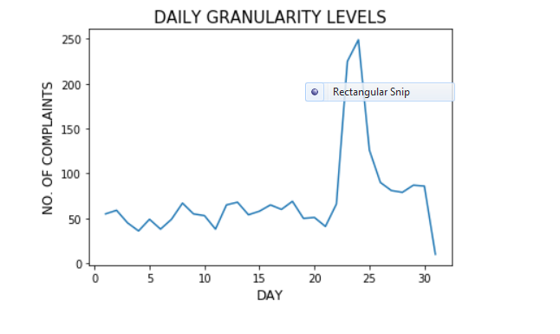

**3] Frequency table of Lodge Complaints**

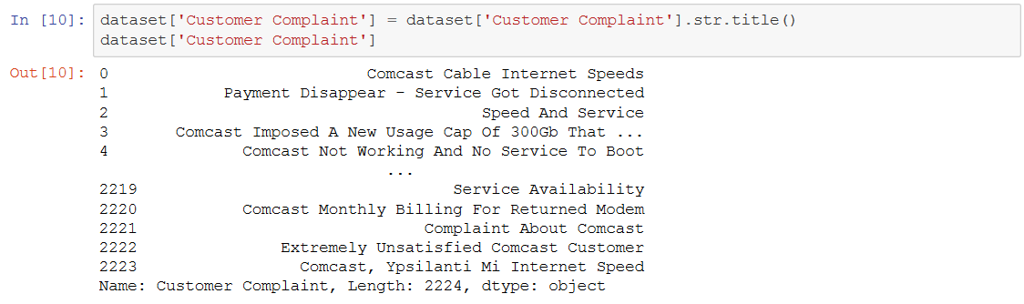

.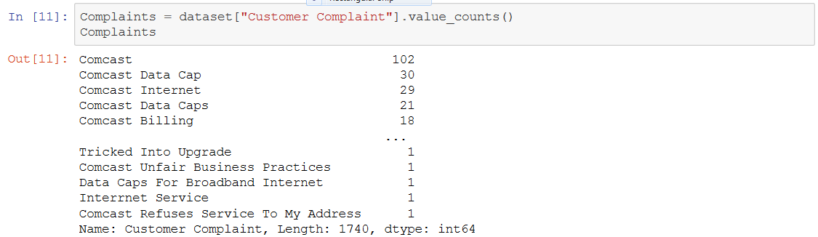



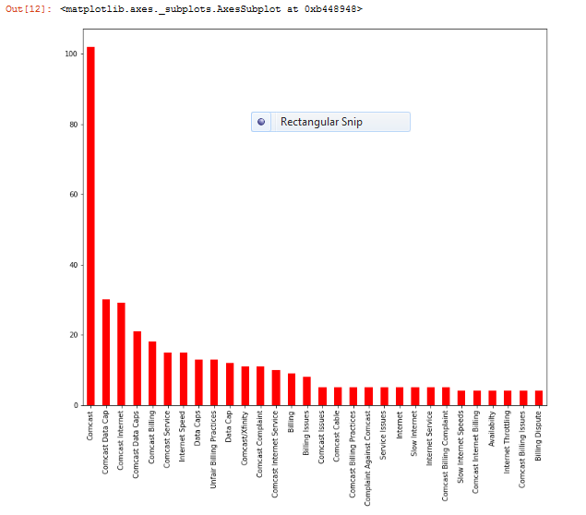

#### Insight:-

##### - As shown in chart it is clearly shows that Comcast , Comcast Data Cap & Comcast Internet is highest type of complaints.

### **4] Which complaint types are maximum & Which State has lodge maximum complaints.**

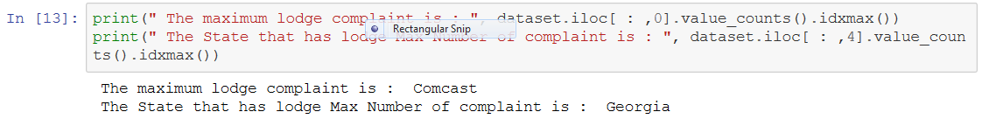

### **5] Create a new categorical variable with value as Open and Closed**

###### -(Open & Pending is to be categorized as Open and Closed & Solved is to be categorized as Closed)



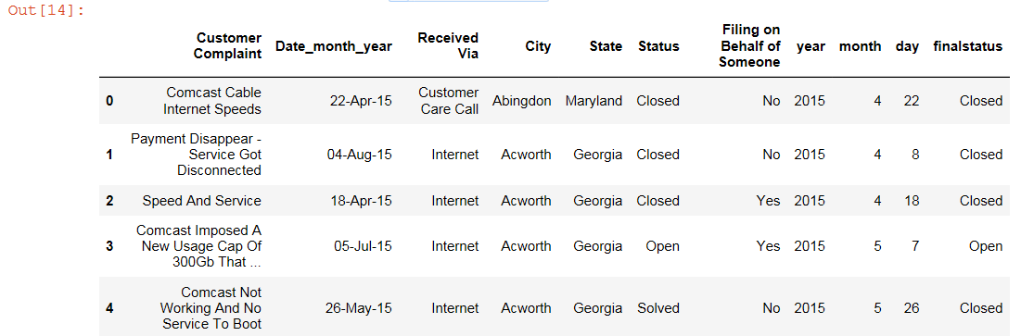

* + We create new Variable as finalstatus.

### **6] Provide state wise status of complaints in a stacked bar chart**



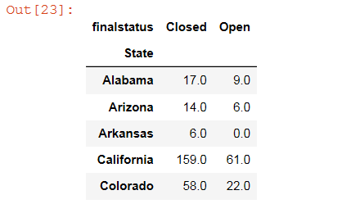

##### Provide state wise status of complaints in a stacked bar chart



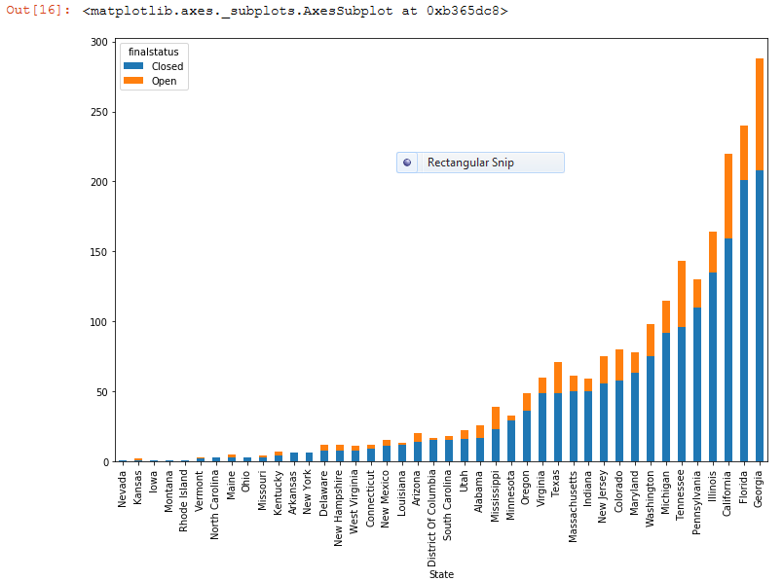

#### Insight:-

##### - As shown in graph Georgia, Florida, California these are few state which has highest no of complaints also maximum no. of complaints resolved

**7] Which state has the highest percentage of unresolved complaints**



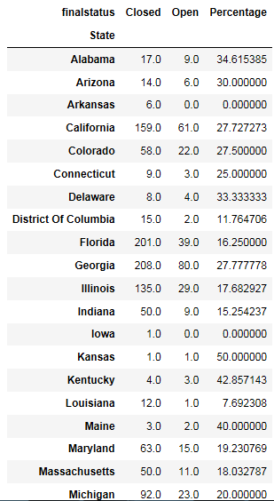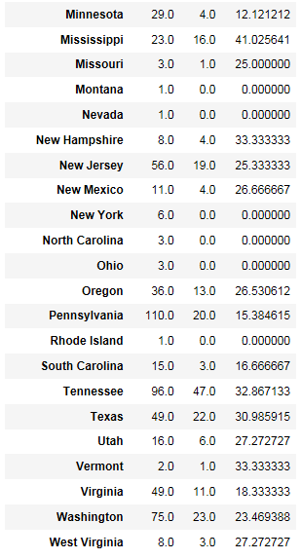



The City which has more no. of unresolved complaints

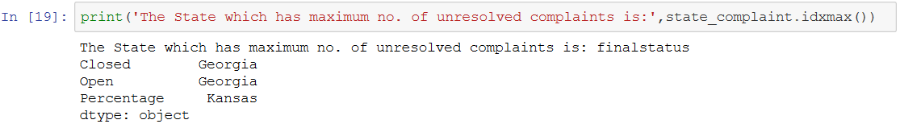

#### **Insight** :-

##### --The State which has maximum no. of unresolved complaints is Georgia - Out of total 288 complaints 208 is closed & 80 is Open

##### --The State which has highest percentage of unresolved complaints is Kansas - Out of total 2 complaints 1 is closed & 1 is Open which is 50%

### **8] Provide the percentage of complaints resolved till date, which were received through the Internet and customer care calls**

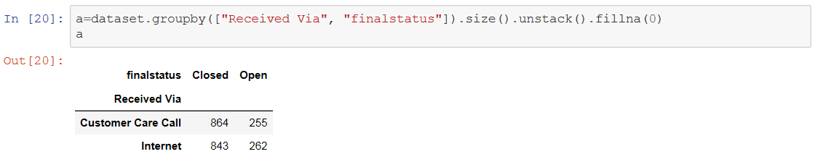

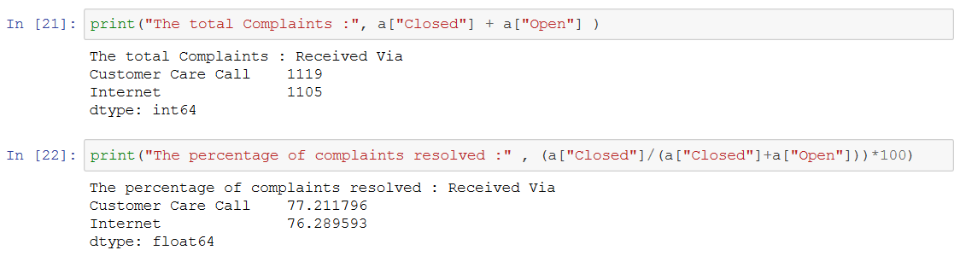

#### Insight :-

#### 

##### - Total no. complaints resolved received Via Customer Care Call is 77.21%

##### -- Total no. complaints resolved received Via Internet is 76.28%